- ANSI-SPARC architecture:
  - Conceptual structure (schema) - just 1
  - External structures (ex. views) - there can be several
  - Physical (internal) structure (data files, indexes etc.) - just 1
  - No such thing as a symbolic structure
- Data independence -
  - Logical - apps + external schemas are not affected by changes in the conceptual structure
  - Physical - apps + ext sch are not... physical structure
- From the simplest to the most complex: field, record, table, database
- Data description model can be used to describe: the structures of the data, relationships with other data, consistency constraints
- The rows in a relational table are not ordered, the records are distinct - but DBMSs allow duplicates
- Degree of a relationship set = the no. of entity sets the participate in that rel
  - The degree of a projection < .. of the original table
- Optimizer - produces an efficient execution plan for query eval, based on storage information
- Multiple candidate keys can be declared using UNIQUE; one of them can be chosen as the primary key
- We can have a multiple FK that references a multiple PK
- FK can be null
- An att can be a PK and FK at the same time
- Key = a restriction defined on an entity set; a set of attributes with distinct values in the entity’s set instances
- Integrity constraints = conditions specified on the DB schema, restricting the data that can be stored in the DB (includes key constraints, FK constraints)
  - Key constraint = a constraint stating that a minimal subset of atts in a relation is an unique identifier for every tuple in the relation
  - Superkey = set of fields that contains the key
- 3-valued logic (true, false, unknown = null)
- “expression = ANY (subquery)” ⇔ “expression IN (subquery)”
- “Expression <> ALL (subquery)” ⇔ “expression NOT IN (subquery)”
- Copy data from one table to another: “INSERT INTO T2; SELECT * FROM T1”
- SELECT can contain arithmetic operations
- SELECT, FROM - mandatory; HAVING - optional
- HAVING cannot contain row-level conditions because it works with groups
- Patterns: "%" - 0 or more arbitrary characters, "_" - any one character (used with LIKE)
- Can’t group by a subquery
- SELECT R.* ⇔ select all the columns in R, ex.
SELECT R.*
FROM R
RIGHT JOIN whatever ON whatever
- LEFT JOIN = inner join + the left operands which don’t match the condition (their columns are filled with NULL); same idea for RIGHT JOIN
- If we have a FROM query, we need to give it an alias
- Processing order: from, where, group by, having, select, distinct, order by, top
- Functional dependency: left side = determinant; right side = dependent
- Functional dep properties:
  - K - key of R, Ꞵ - key of a subset of R => K -> Ꞵ
  - Ꞵ ⊆ 𝛼 => 𝛼 -> Ꞵ (trivial func. dep., reflexivity)
  - 𝛼 -> Ꞵ => Ɣ -> Ꞵ, for any Ɣ : 𝛼 ⊂ Ɣ
  - a -> b and b -> c => a -> c (transitivity)
  - a -> b => a u c -> b u c (augmentation)
- Prime attribute if it’s included in a key K; non-prime otherwise
- B is fully functionally dependent on A if A -> B and B doesn’t depend on any proper subset of A
- Multivalue dependencies - each value from the determinant is associated with a set of values, not with just one, denoted by “-> ->”
- Join dependency (JD) - we project an R[A] onto R1[𝛼1] … Rn[𝛼n] => R satisfies the JD {𝛼1, …, 𝛼n} if R = R1 * … * Rn
- Normal forms:
  - 1NF ⊂ 2NF ⊂ 3NF ⊂ BCNF ⊂ 4NF ⊂ 5NF
    - If not 1NF => not 2,3..NF; if not 2NF => not 3,BC..NF and so on
  - 1NF = no repeating attributes
  - 2NF = 1NF + every non-prime att is fully functionally dependent on every key of the relation
  - 3NF if for any non-trivial X -> A, X is a superkey or A is a prime att
  - (Boyce-Codd) BCNF if every determinant (left side of a func dep) is a key
    - Most desirable form
  - 4NF if for every multi-valued dep a ->-> b, either one is true
    - b ⊆ a or a U b = R
    - a - superkey
  - 5NF = every non-trivial join dependency (JD) is implied by the candidate keys in R
    - A JD *{𝛼1, …, 𝛼n} is trivial if any 𝛼i is the set of all atts of R
    - … is implied by the candidate keys in R if ALL 𝛼i are superkeys in R
- Armstrong’s axioms: reflexivity, augmentation, transitivity
- Rules derived from AA
  - a -> b and a -> c => a -> b u c (union)
  - a -> b u c => a -> b and a -> c (decomposition)
  - a -> b and b u c -> d => a u c -> d (pseudotransitivity)
- 𝛼+ = closure of 𝛼 under a set of fds
- Example: Show that some fds are in 𝛼+
We have a relation R = {a … f} and 𝛼 = {a -> b, a -> c, cd -> e, cd -> f, d -> e}. Show that the following fds are in 𝛼+
a -> bc: union of a -> b and a -> c
cd -> ef: union of cd -> e and cd -> f
ad -> e: a -> c / augment with d => ad -> cd; from cd -> e through transitivity => ad -> e
ad -> f: pseudotransitivity a -> c and cd -> f

- Algorithm for computing 𝛼+ 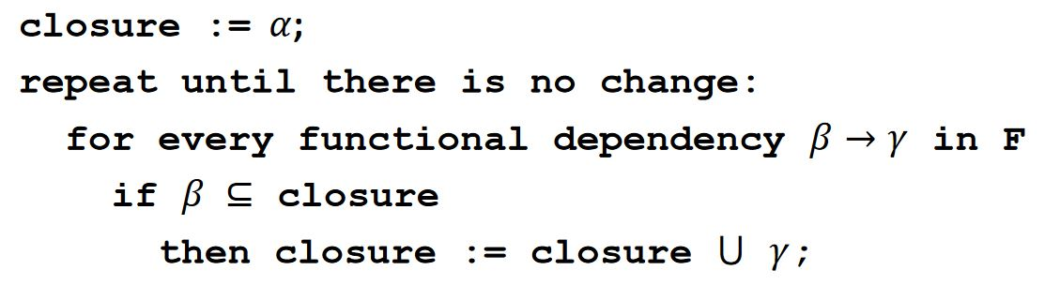
- Example: Compute 𝛼+
R = {a … f} and F = {a -> b, a -> c, cd -> e, cd -> f, d -> e}
𝛼 = {a, d} (given)
𝛼+ = {a, d}
a -> b => 𝛼+ = {a, b, d}
a -> c => 𝛼+ = {a, b, c, d}
cd -> e => 𝛼+ = {a, b, c, d, e} (because both c, d were in 𝛼+)
cd -> f => 𝛼+ = {a, b, c, d, e, f} (same reason)
d -> e => we don’t add it because E already is in 𝛼 => no change at this step => stop => 𝛼+ = R

- F, G - sets of fds => F ≡ G (equivalent) if F+ = G+
- Minimal cover Fm if
  - Fm ≡ F
  - Right side of every dependency in Fm has a single att
  - Left side .. is irreductible (if we remove an att from it, we modify Fm’s closure)
  - No dependency in Fm is redundant (if we remove it, we modify the closure)
- Example: compute Fm
R = {a … d}; F = {a -> bc, b -> c, a -> b, ab -> c, ac -> d}
Use decomposition on a -> bc => a -> c, a -> b (which already was in, so we don’t add it again) => {a->b, a->c, b->c, ab->c, ac->d}
a -> c / augment with a => aa -> ac => a -> ac; we know ac -> d => a -> d (transitivity); now ac->d becomes redundant, we replace it with a -> d => {a->b, a->c, b->c, ab->c, a->d}
a -> c / augment with b => ab -> cb => (decomposition) ab -> c (it’s already in, we can remove it) => {a->b, a->c, b->c, a->d}
b -> c can be obtained as a -> b and b -> c (transitivity) => remove b -> c
Fm = {a->b, a->c, a->d}

- Just by looking at an instance, we can only say that a func. dep is satisfied or not, we can’t conclude that it’s specified on the schema
- Algebra symbols
  - 𝜎_{𝐶}(R) = select * from R where C; distributive over set diff, intersection, union
  - π_{𝛼}(R) = projection; select (distinct?) 𝛼 from R (𝛼 can specify multiple columns); it’s distributive only over union
  - R1 X R2 = select * from R1 cross join R2 (cross product); the schema will contain all the atts of R1 followed by the atts of R2
  - R1 U R2, R1 - R2, R1 ∩ R2 = union, set diff, intersection
  - R1 ⮿_{Θ}R2 = .. inner join on Θ (condition join)
  - R1 * R2 = natural join; schema will contain the union of the atts (= all atts, common ones appear only once); returns 1 relation instance
  - R1 ⋉_{c} R2 = left (outer) join on c; the reversed symbol is right (outer) join..
  - R1 ⋈_{c} R2 = full (outer) join on c; schema will contain all the atts of R1 followed by the atts of R2
  - R1⊳R2 = left semi join; the reverse is right semi join
    - Left.. = the tuples in R1 that are used in the natural join; right.. = ..R2
  - R1 ➗ R2 = division
  - 𝛿 = duplicate elimination
  - S _{{list}} (R) = sort
  - 𝛾_{{𝑙𝑖𝑠𝑡1} 𝑔𝑟𝑜𝑢𝑝 𝑏𝑦} _{{𝑙𝑖𝑠𝑡2}} (R)
  - 𝜌 = renaming operator (nush ce plm e cu asta)
- All the operators (without duplicate elim, sort, group by) can be obtained from {𝜎,𝜋, ×, ∪, −} (= independent set of operators) (see l7, p3 on how to do it)
- If there are multiple triggers defined for the same action, they are executed in a random order
- DBMS structure 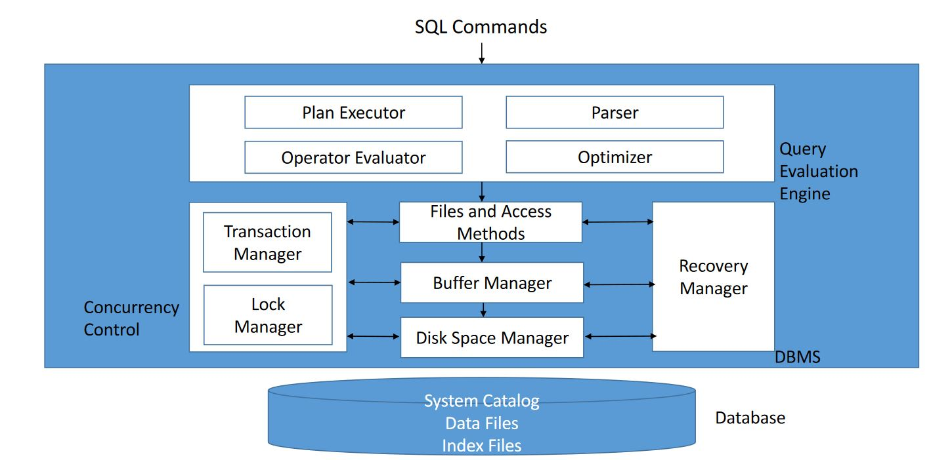
- DBMSs operate on data when it is in memory
- Seek time fmm Carina = time required to move the disk head to the desired track (smaller platter size => decreased seek time)
- Disk access time (magnetic disk) = seek time + rotational delay + transfer time
- Block = unit of data transfer between disk and main memory
- DSM = disk space manager; monitors disk usage, it commands to (de)allocate, read / write a page
- BM = buffer manager; brings new data pages from disk to main memory as they are required, manages the available main memory
  - Replacement policies - LRU (least recently used), MRU, random, clock replacement, toss-immediate
  - Buffer pool (BP) is made of frames, which can fit a page
  - Each frame has
    - pin_count = no. of current users on the crt frame; only those with 0 can be replaced; initial value = 0
    - dirty = true if the page has been changed since it was brought to the frame; initially off
  - When a page is requested
    - If the page is in the BP, increase its pin count => done
    - Else, select a frame (FR) to replace using the replacement policies; if the old frame was dirty, write it on the disk; pin_count(FR)++, the new page is read by the BM in that frame
    - If the BP is full, the operation may be aborted, or it waits
  - It may pre-fetch pages
- Heap files
  - Simplest file structure, unordered records, best when we need to scan all the records
  - Can use
    - Doubly-linked list - it needs a header = stored by the dbms; it has 2 lists, for full / free pages
    - Directory of pages
- Index
  - Stored on the disk, associated with a table or view
  - Speeds up equality / range select queries on the search key
  - If we change the data => the indexes need to be updated
  - hashed files - very good when searching for equality
  - Data entry is:
    - A1 - the actual data record with search key value = k
    - A2 - <k, rid>, rid = id of a data record with sk = k
    - A3 - <k, list of rid> …
    - In general, a2, a3 are smaller than a1
  - Clustered
    - A1 - always clustered
    - the order of the data records is close to / same as the order of the data entries
    - Includes all the columns in a table
    - At most 1 / collection of records
    - When creating a PK, if there’s no clus. on that table (and we don’t specify unclustered) => create an unique cl. Index
    - Organized as a B+ tree
  - Unclustered:
    - A2, A3 - are clus. only if the data records are ordered on the search key, which is uncommon in practice => A2, A3 are usually unclus
  - Primary index - contains the PK; unique index = contains a candidate key
    - secondary = not primary (in our terminology, but in other places this might mean that it’s just unclus); it can be unclus
  - Primary / unique can’t contain duplicates, secondary can
  - Composite SK - contains several keys
  - Covering index - contains all the columns that are necessary in a query
  - Filtered index - can be created with a WHERE => only used when it satisfies that condition
- ISAM = Indexed Sequential Access Method
  - Not very good when doing lots of inserts / deletes
  - Search complexity: log_{c}m (c = children per index page, m = primary leaf pages)
- 2-3 tree
  - All terminal nodes on the same level
  - If a non-terminal node has 1 key => 2 subtrees: one with values < key, the other > key
  - If .. 2 keys (key1 < key2) => 3 subtrees: first < key1 < second < key2 < third
  - Values in the tree are distinct
- B-tree of order m
  - Generalization of 2-3 tree (= b-tree of order 3)
  - All terminal nodes on the same level
  - Every non-terminal, non-root node has between ceil(m / 2) and m subtrees
  - A node with p subtrees has p-1 ordered values
  - 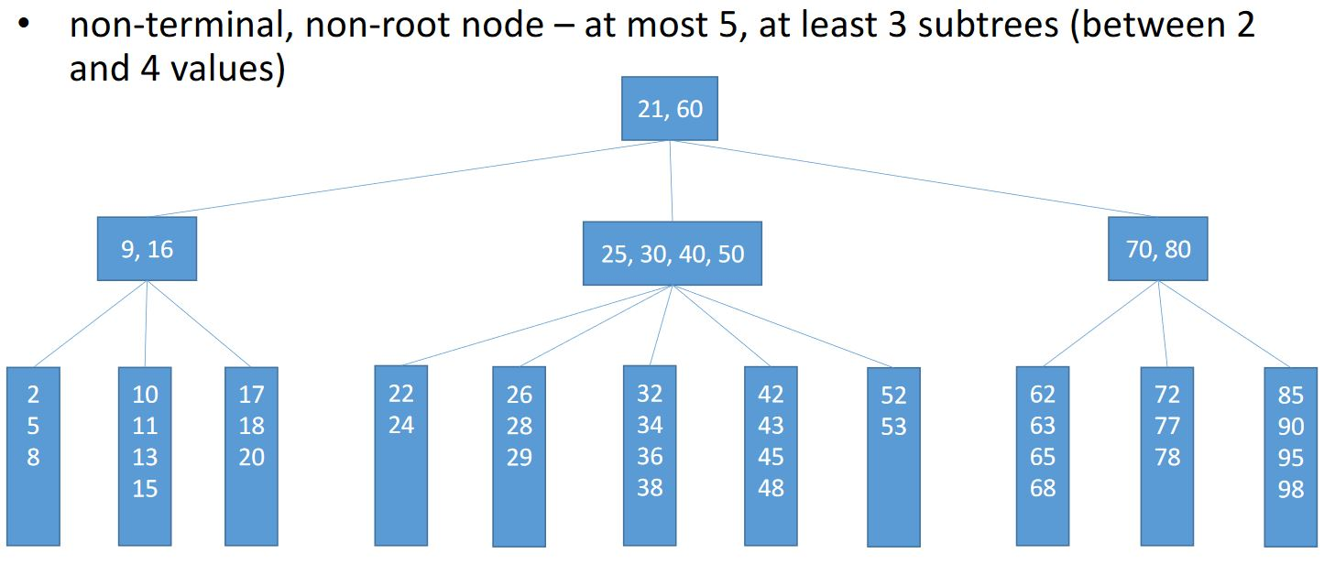
- B+ tree
  - Variant of the B-tree
  - Uniform search time; few I/O ops needed for searching; ideal for range selection
  - Much better than ISAM for insert / delete etc.
- Hash-based indexing - ideal for equality selections
- Static hashing - the classic one (SDA gen)
- Extendible hashing - there’s a directory which points to the buckets, each determined by the last k (= depth) pro digits of the values; when a bucket becomes full, we split it into 2 buckets determined by the last k + 1 digits and we double the size of the directory
- The client generates SQL statements and sends them to the server, which syntactically analyses + evaluates them and sends the results back
- Table scan - high transfer time for large tables (the slowest)
- Index seek - when we search for a key value (using = ) that we have indexed (the fastest)
- Index scan - the search condition can depend on either a key or a non-key att; some mem. blocks may be read multiple times
- Joins are used in practice more often than cross-products. The sooner we apply selections / projections in the join implementation, the better
- Some algorithms for cross-join, (indexed) nested loop join, merge join, hash join (found here)
- Algebra equivalences
  - 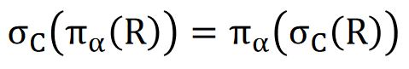 (second is more efficient)
  - 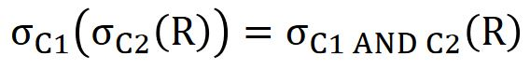(second - more eff because it only does one pass of R)
  - 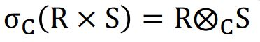(condition join - more eff)
  - 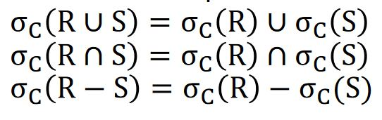(if the schemas of R and S are compatible)
  - 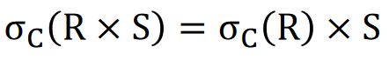(if C contains only atts from R)
  - 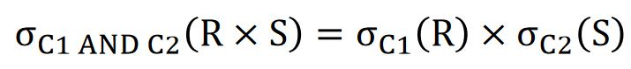(if C1 contains only atts from R, C2 .. S)
  - (if C2 is a join condition between R and S)
  - 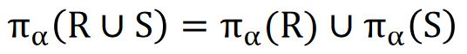
  - (𝛼1 = atts from R that appear in 𝛼 or C, 𝛼2 = … from S…)
- Intersection and union are associative and commutative
- Cross-product and natural join are associative
- When using the cross-join algorithm, the order of the data sources is important
- Surrogate key = key that isn’t obtained from the domain of the modeled problem
- DB design stages
  - Requirement analysis
  - Conceptual design
  - Logical design
  - Schema refinement (normalization, eliminate redundancy)
  - Physical design (ex. indexes)
- We can have tables that reference themselves (recursive relationship); if there we have ON DELETE CASCADE => error; same if we have two tables that reference each other
- The M:M table is also called join table
- Reduce fragmentation
  - In a heap - create then drop a clus index
  - In an index - ALTER INDEX REORGANIZE (if small fragmentation), ALTER INDEX REBUILD (if large fragmentation) or drop + recreate index
- Indexed views
  - cannot reference other views
  - the index must be clus + unique;
  - only allowed aggregation operators are sum, count
  - subqueries, outer joins, set operations etc are not allowed
  - 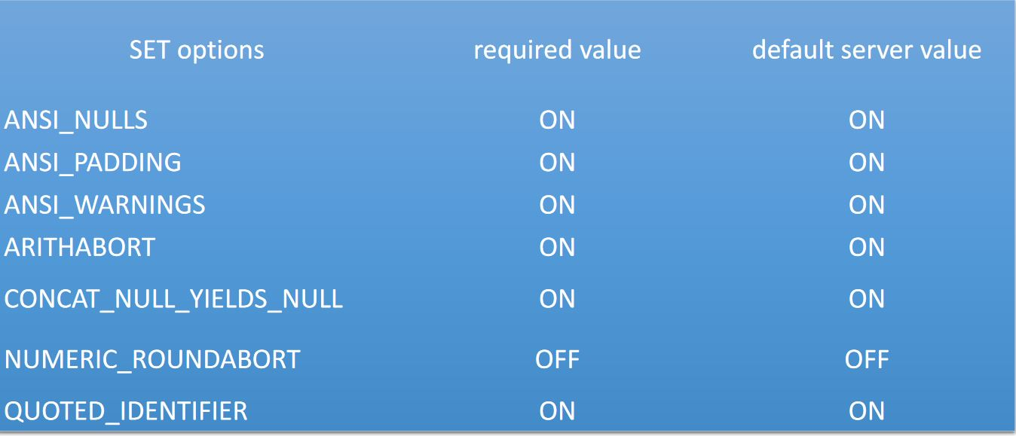
- WAITFOR TIME ‘4:37’ => execution continues at 4:37
- Traditional dbms -> one-shot query (executed on the current instance of the data)
  - Human active, DBMS passive model (HADP)
- Data stream = temporal sequence of values produced by a data source, potentially infinite; data is associated with timestamps; we can have data stream management sys
- Event = elementary unit of information on a data stream (the equivalent of a record)
- Sliding window = contiguous portion of the data stream, it has a size and a step size
- Continuous query - perpetually running, DAHP

